EPSRC Centre for Doctoral Training in

Industrially Focused Mathematical Modelling

[Delete & Insert Photo/Image]

Title of Project

Name of Student

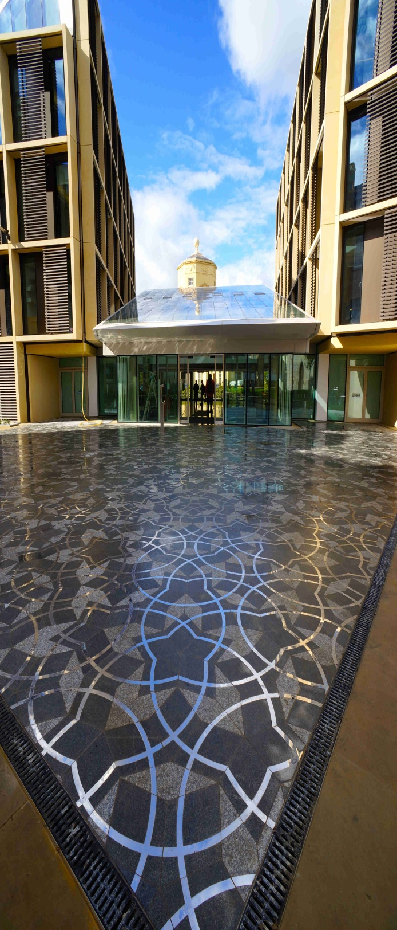

Contents

1. Introduction 2

Background 2

Other subheadings – use this font colour and size; no numbering 2

2. [Your problem] 2

Glossary of terms 3

Mathematical model 3

Comments 3

3. [Results parts; put in title relating to the results you will get, eg “Plume evolution”; use as many main headings as neede]d 3

[Eg: Model 1: Cleanser-soluble product etc] 3

3

[Eg: Dimensionless parameters] 3

Expanding the model 3

4. Discussion, Conclusions and Recommendations 4

[Subtitles should convey the sub-challenges you have worked on, eg “Bean-moisture model”] 4

Reaction and decontamination 4

5. Potential Impact 4

References 4

# Introduction

## Background

Useful comments go in boxes at the side like this one. You can tether the boxes to stay alongside bits of text you edit

## Other subheadings – use this font colour and size; no numbering

Put in the background to your mini-project challenge(s) and give a forward look to the rest of this lay report.

Remember that the audience for your Lay Report are not mathematicians (eg the people at EPSRC), so you should explain any mathematical jargon that you use. You have 6 pages + front cover+ TOC page.

Example: A one-dimensional model enables us to consider the vertical flow of the contaminant, most relevant in large spills.

# [Your problem]

In this section, describe the problem you are focusing on in your Miniproject. A picture is essential. Throughout the document, pictures/graphics should be centred in this column, numbered from 1, and have a label beneath in the following format:

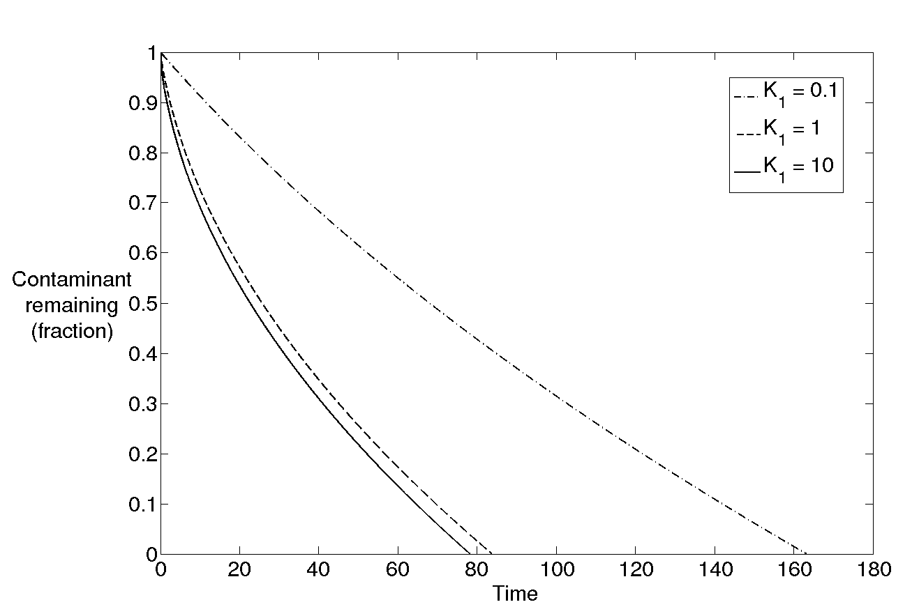 **Figure 3: The current amount of contaminant relative to the initial amount of contaminant for different values of $K_{1}$, in the case where the reaction product is soluble in the cleanser. As in all graphs in this report, time is given here in *dimensionless* form (*i.e.* the unit of time used is $t_{d}={h^{2}}/{D_{c}}$ rather than seconds or hours).**

## Glossary of terms

This is a useful summary of the key terms and ideas that you will need to appeal to during the rest of this report.

Eg:

* Capillary action: Surface tension can act as an attractive force (e.g. between water and glass) or a repulsive force (e.g. between mercury and glass) between two materials. Capillary action refers to the motion induced by these surface tension forces, such as the movement of water along or up a sheet of kitchen paper.

## Mathematical model

Describe the assumptions that you make, and then the key features of the model. Only put in equations if they are absolutely necessary.

## Comments

* Put in some comments to further highlight what you’ve done and what you plan to do with the model in the rest of the report.

# [Results parts; put in title relating to the results you will get, eg “Plume evolution”; use as many main headings as neede]d

Key results should be put into boxes, Eg: Long-term kinetics are dominated by diffusion of the cleanser from the surface.

Describe your results – break the section down into the different models/scenarios that you looked at; don’t underestimate the power of discussing the key dimensionless parameters that govern a system, if appropriate. Include results graphs and describe both what is seen and what the implications are. Include nondimensional parameters used, if allowed by the company; if not, put in parameter ranges.

## [Eg: Model 1: Cleanser-soluble product etc]



## [Eg: Dimensionless parameters]

## Expanding the model

* Describe how to expand the model to make it more realistic
* Are there any experiments that could be done to help tie down the parameters?

# Discussion, Conclusions and Recommendations

Eg: We can understand the reaction kinetics by varying only two parameters ( $K_{1}$ and B).

## [Subtitles should convey the sub-challenges you have worked on, eg “Bean-moisture model”]

Only have one or two paragraphs per subtitle. Discuss the implications of the results and what you conclude from them, and add in recommendations (if appropriate).

## Reaction and decontamination

# Potential Impact

Work with your industrial supervisor and write statements about the short, medium and longer term impact of the work to the company. This can include some speculation about future work needed to capitalise on results if necessary. Further, describe the potential impact outside the company.

Include some direct quotes from your industrial supervisor, in the format:

Colin Please, Head of Nice Mathematics, [commented/said/reported etc] “*Your maths is all fantastic and now the company will make a lot of money*”

## References

Only put in references if they are crucial to the lay report. Otherwise leave them out and delete this section.

Format for references

1. CJW Breward et al (2015) *What a lovely report this is*. J Snot. Flick. **2**, 3-8.